**Having Empathy Means:**

**\*Listen** without interrupting.



**\*Remember** when you felt the same way.



**\*Imagine** how YOU might feel.

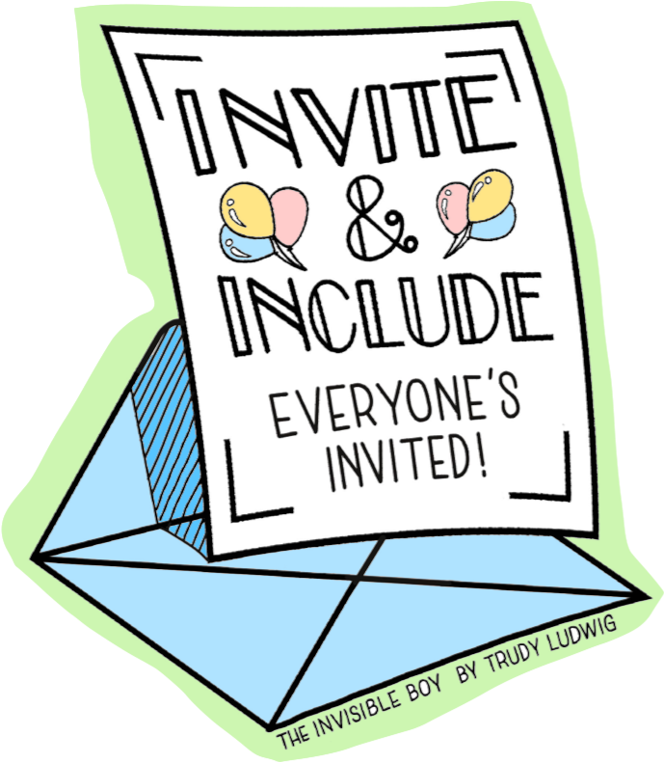

**\*Ask** what the other person is feeling.



**\*Show** you care with words and actions.



**\*Be** an UPstander.