2024 Favorite Project Cornerstone Book of the Year
Choose Your Favorite Book
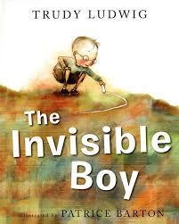  The Invisible Boy |  |   Eyes That Kiss the Corners
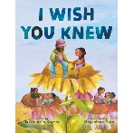  I Wish You Knew |  | 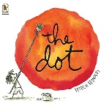  The Dot
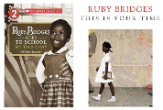  Ruby Bridges Goes to School/This is Your Time |  | 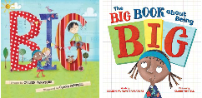  BIG

Clovis Keeps His Cool

2024 Favorite Project Cornerstone Book of the Year
Choose Your Favorite Book
The Invisible Boy |  | Eyes That Kiss the Corners
I Wish You Knew |  | The Dot
Ruby Bridges Goes to School/This is Your Time |  | BIG
Clovis Keeps His Cool

