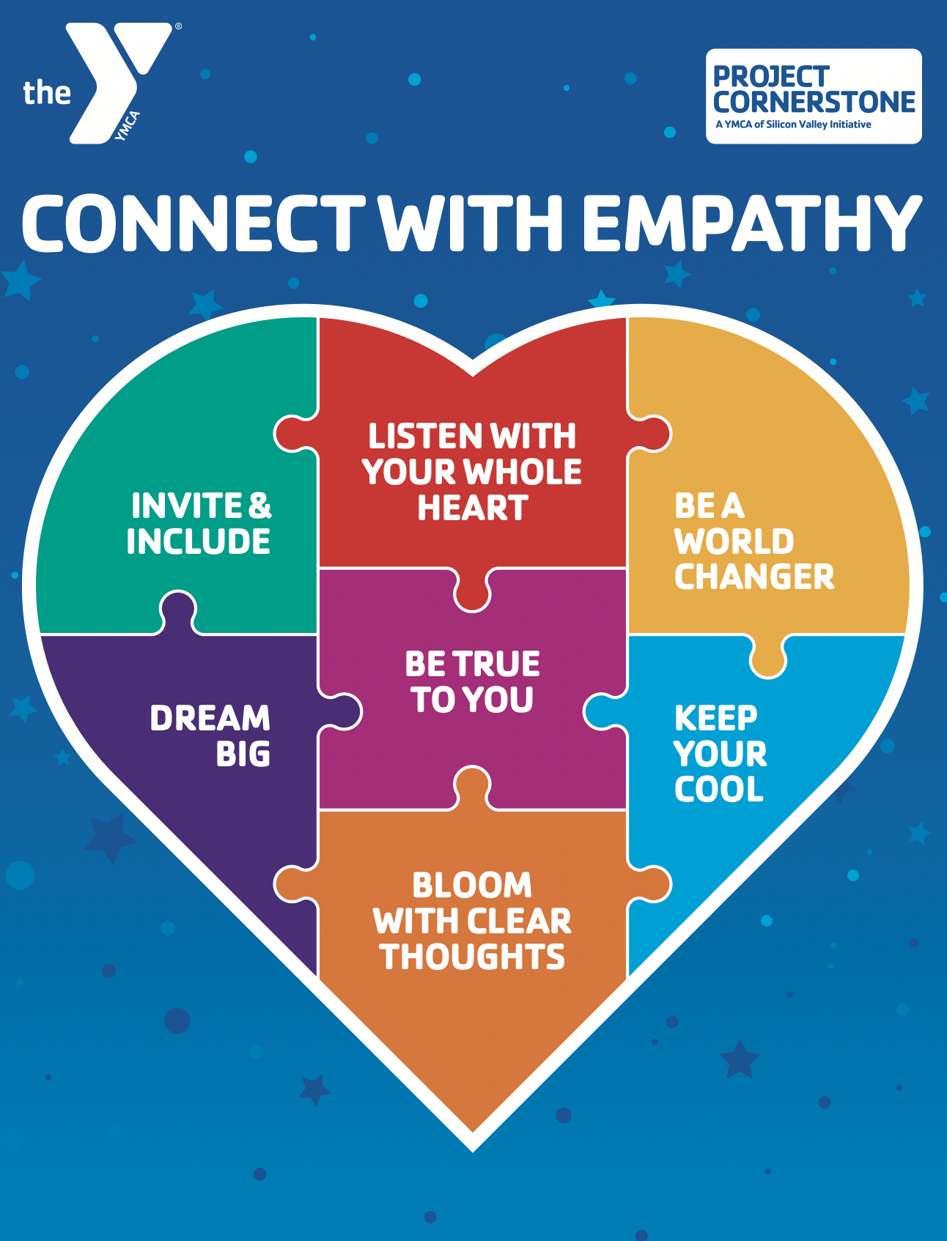  Connect with Empathy |  | Connect with Empathy |  | Connect with Empathy
Connect with Empathy |  | Connect with Empathy |  | Connect with Empathy
Connect with Empathy |  | Connect with Empathy |  | Connect with Empathy
Connect with Empathy |  | Connect with Empathy |  | Connect with Empathy
Connect with Empathy |  | Connect with Empathy |  | Connect with Empathy
Connect with Empathy |  | Connect with Empathy |  | Connect with Empathy
Connect with Empathy |  | Connect with Empathy |  | Connect with Empathy
Connect with Empathy |  | Connect with Empathy |  | Connect with Empathy
Connect with Empathy |  | Connect with Empathy |  | Connect with Empathy
Connect with Empathy |  | Connect with Empathy |  | Connect with Empathy

