ABC CHAMPION YEAR TOOL KIT

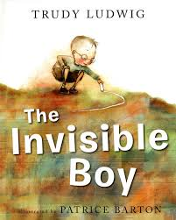
The Invisible Boy
- Invite, include, and make everyone feel welcome.
- Identify social cues (verbal, physical) to determine how others feel.
- Build relationships by filling buckets with kindness.
- Behave and speak in an empathetic manner by demonstrating genuine care, understanding, and consideration for others.
- Create a caring school climate where students show respect for one another.

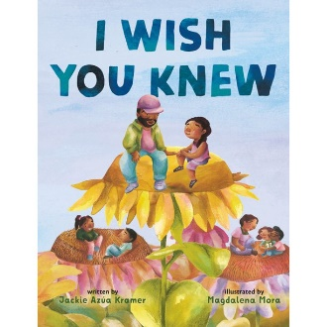
I Wish You Knew
- Develop and practice empathy skills such as active listening, perspective-taking, and compassion.
- Promote empathy as a means of resolving conflicts, reducing stress, and building stronger connections with others.
- Examine their own biases, assumptions, and prejudices that may hinder the ability to have empathy for others.
- Identify caring adults and support systems available to advocate for them.

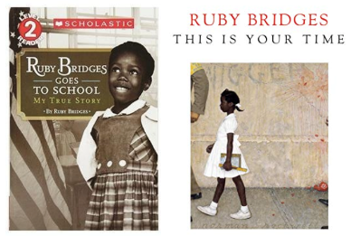
Ruby Bridges Goes to School/Ruby Bridges This is Your Time
- Understand that stereotypes lead to discrimination.
- Be a world changer by standing up for the rights of others.
- Respect differences, accept others, and celebrate diversity.
- Build bridges and encourage dialogue about racism and biases between different groups.

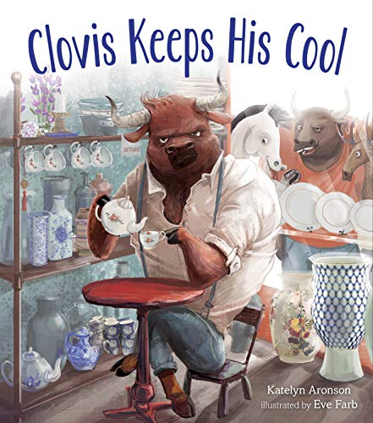
Clovis Keeps His Cool
- Recognize emotion by looking inside themselves and in others to identify and connect with feelings being expressed.
- Allow the feelings to stand and move through them in appropriate ways.
- Take time to understand the different ways people express their emotions and how to respond to these expressions in an empathetic manner.
- Learn ways to reconsider, resolve conflict, and offer second chances.

Eyes that Kiss in the Corners
- Understand and express gratitude for the people in our lives.
- Celebrate your authentic self and its contribution to the diversity of our world.
- Develop a greater understanding and respect for people from different backgrounds.

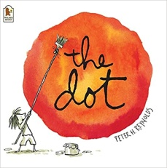
The Dot
- Use a growth mindset to discover and grow as a person.
- Use personal power to change mud thoughts into clear thoughts.
- Tap into the power of positive thinking by believing in their own abilities and unique talents.
- Understand the positive impact that kind words and support can have on someone’s confidence and motivation.
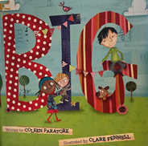
BIG
- Grow and change behavior by thinking how their words and actions will affect others.
- Be kind to self, to others, and to earth.
- Do intentional acts of caring and kindness as they can make a BIG difference in someone’s life as well as their own.
- Use your own passions and talents to improve the lives of those around you.

