**4 Corners - Review of Champion Year**

This is a fun way to get the kids to think about all the stories and characters you read about this year.

1. Print out these pages and tape them around the classroom.
2. Break the class into small groups and send them to one of these questions to discuss.
3. Have them share with the whole class afterward.

SKITTLES IDEA: One way to break the kids into groups is to pass out Skittles and have each kid pick a color without telling them why.



Use a colored piece of paper (that match Skittles colors -green, yellow, orange, red, and brown/purple) as background behind each question. Have the kids go stand by the color they chose.

Or, just have the kids pick a color they like.

**What was your favorite book?**

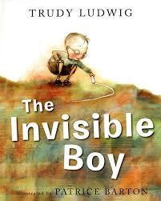 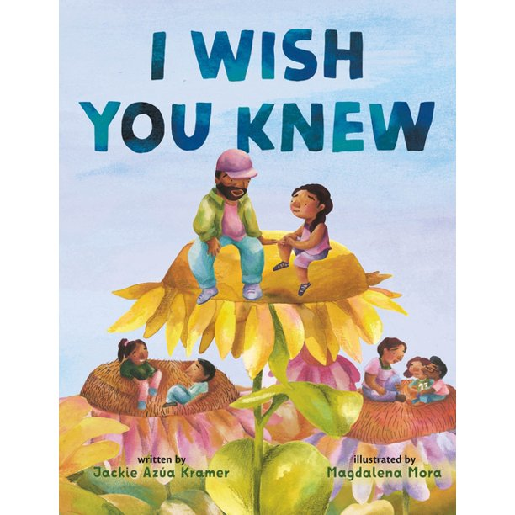 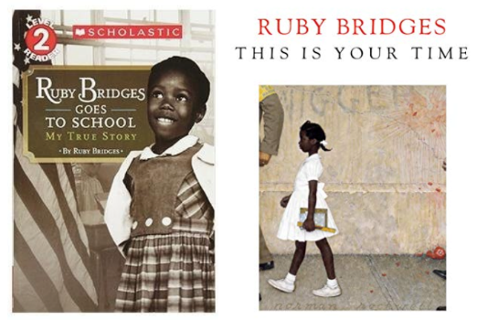 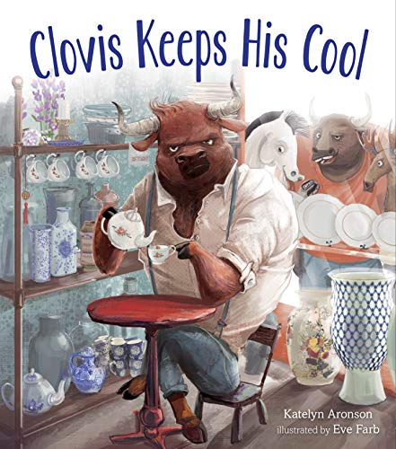

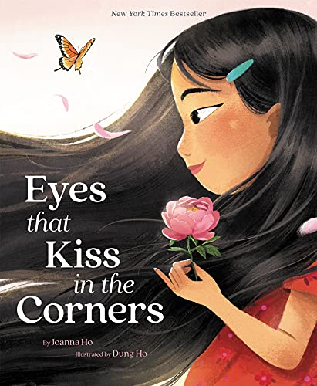 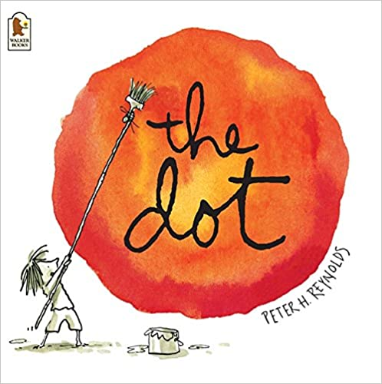 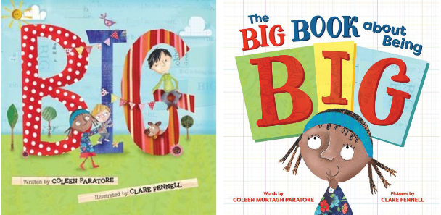

**Which character would you like to hang out with? Why?**

 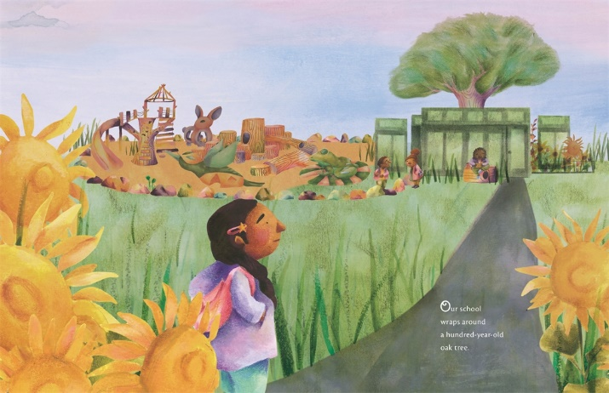 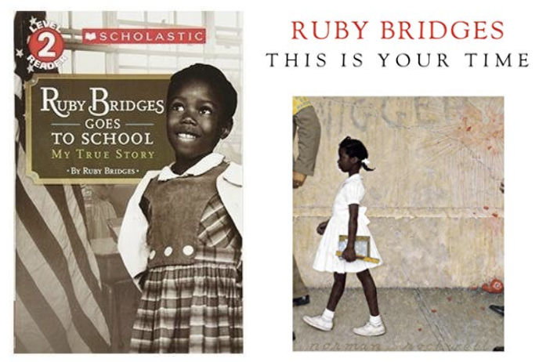

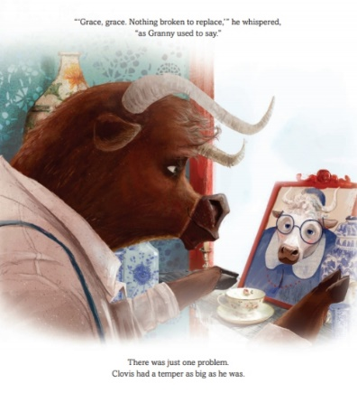 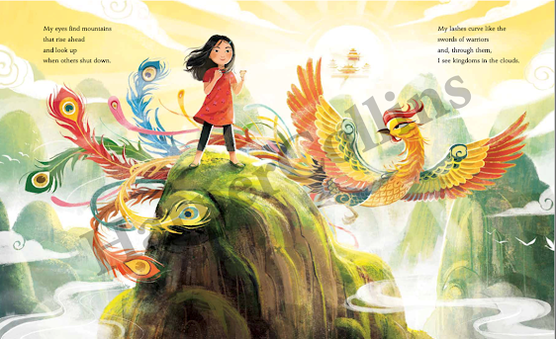 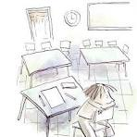



**Who are the caring adults who   
help these characters?**

**Who are the caring adults who help you?**

 

  

**What ABC tools did you learn from these books?**

   

  