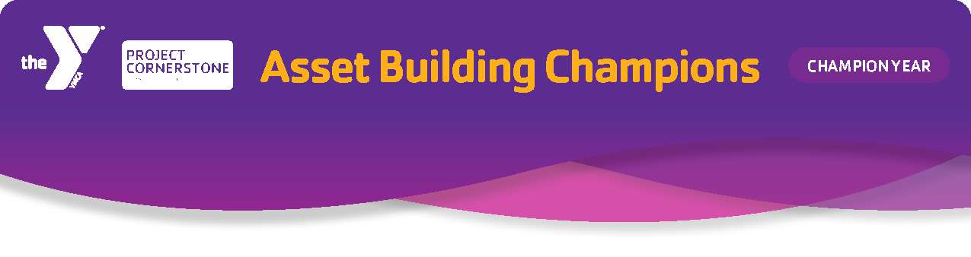
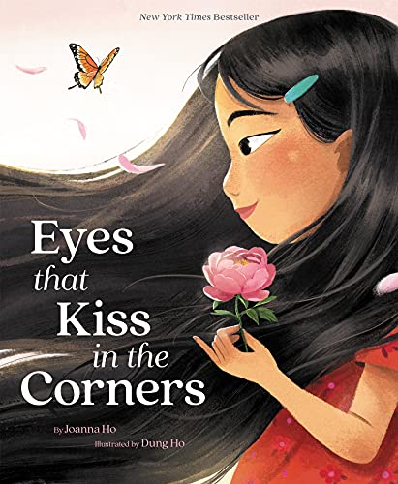
Book of the Month
Title: Eyes that Kiss in the Corners
Author: Joanna Ho
Illustrator: Dung Ho
Publisher: Harper
Key Phrase
Be True to You

Joanna Ho writes this book from her personal experience. Eyes that Kiss in the Corners promotes students’ understanding and appreciation for their heritage at a young age. When people know more about their own culture, they are better able to understand and appreciate the culture of others. In this story, a young girl noticies that her eyes look different from her friends’ eyes. Instead of their big, round eyes, her eyes “kiss in the corners and glow like warm tea”. She realizes that her eyes are like her mother’s, her amah’s, and her little sister’s and they are all beautiful. This book is about recognizing your own inner strength, leading to a path of self-discovery and confidence.

Social Emotional Learning (SEL):
Self-Awareness (identify emotions, self-perception/identity, recognizing strengths, sense of self-confidence, and self-efficacy)

Developmental Assets:
Support - #1 Family Support, #2 Positive Family Communication, #3 Caring Adults, #5 Caring School Climate
Empowerment - #7 Community Values Youth, #10 Safety
Positive Values - #26 Caring, #27 Equity and Social Justice, #29 Honesty
Social Competencies -#33 Interpersonal Competence, #34 Cultural Competence
Positive Identity - # 37 Personal Power, #38 Self-Esteem, #41 Positive Cultural Identity

Developmental Relationships:
Express Care - Listen, Believe in Me, Be Warm, Encourage
Expand Possibilities – Inspire, Broaden Horizons, Connect

- Students will express gratitude for the people in their lives.
- Students will celebrate their authentic self and their contribution to the diversity in our world.
- Students will develop a greater understanding and respect for people from different backgrounds.

It is important to be mindful and reflective of your own identity. Understand that you bring your own background, beliefs, behaviors, and biases into the classroom. Some of these biases may cause microaggressions to be exhibited without really realizing it. Microaggressions are subtle, often unintentional actions or comments that convey negative messages toward individuals or groups based on race, gender, sexual orientation, or religion. These everyday slights could be insensitive jokes, backhanded compliments, or implicit bias. Microaggressions may not be overtly hostile or even intended to cause harm, but they reinforce stereotypes and create an environment that marginalizes others. The cumulative impact of microaggressions can be emotionally damaging, contributing to a pattern of systemic discrimination and inequality.

One way to shield yourself from microaggressions is to learn to be your authentic self. This means embracing who you are and all that you are. It means living in alignment with your true values, beliefs, and identity without fear of judgement or societal expectations. It is about your heritage. Take your heritage with you wherever you go and share it with the world. To get a better idea of your cultural reference points, you might ask yourself:
- What is the story of your family and connection to America?
- How did your family identify ethnically growing up?
- What did your culture teach you about success?
- Have you experienced microaggressions?
- Does your family have rituals to promote internalizing cultural values and beliefs?

We are all layers of stories. Share your story by speaking up and being seen and heard, never assuming others understand or know you. It is up to each person to be authentic. By representing your authentic self to the world, you belong without conforming to the dominant culture or popular way of being. We can feel connected to our ancestors and histories and bring these beautiful parts of ourselves to our present selves. As we love ourselves and share ourselves with others, we can build a diverse community where everyone, including those people with a wide variety of identity markers, is valued, celebrated, and known. Remember that being authentic is a lifelong journey that involves ongoing self-reflection and refinement. Believe in yourself and be confident in your ability to shape your life, leading to a path of discovery for your authentic self.

K-2
Your Reflection is YOU
Materials: individual hand mirrors or 1 large mirror

Have students close their eyes and imagine themselves in their best state. Imagine what they’re doing, who they’re with, how that environment makes them feel. Pass out the mirrors and have students look.
- Ask: Who do you see? Say your name! Say it louder. Say it with pride. Whisper it…
- Close your eyes. Take a few breaths. Open them and look at your face. What do you see? Have each child look in the mirror and make observations about their features.
- Encourage them to view their features as wonderful and unique.
- Ask what wonderful features do they see? Talk in detail (shape, colors, size, etc.) about their eyes, noses, faces, smiles, hair, etc.
- Put the mirrors down and as a group look at your hands, what do they see? Yes, a variety of skin tones.
- Say we are all unique and different. It makes us interesting, authentic, and wonderful human beings.
- Discuss with students the idea of being true to yourself or your authentic self.
- Read the story and then follow up with the mirror activity.

Restorative Justice Circle
K-6
Materials: ball or balloon

Usually restorative justice focuses on repairing the harm done when students use bucket dipping behaviors. In this case, it focuses on welcoming newcomers, helping students get to know each other, and building bridges between different cliques and ethnic groups. It is something that can be continued in classrooms with teachers for the rest of the year to create a caring school campus.

Have students form a circle and sit comfortably. Remind them of the rules about not using names, showing respect by using active listening, and agreeing to maintain confidentiality.
To warm up the students, throw or roll the ball to students. Only the student who is holding the ball may speak. Ask them some questions that are easy or fun to answer:
- What is your favorite color?
- What is something fun to do?
- What is your favorite meal?

Once you feel that the students are feeling comfortable, ask students more personal questions:
- What emotion are you feeling right now?
- What is something you like about yourself?
- What is something you would like to change?

Let students talk and share about themselves. If some students show disrespect, remind them gently: “I’m hearing some of you disrespect your classmates. That’s hurtful to use those words. Try to think before you use words like that.” If students put themselves down, remind them of positive affirmations and turning mud thoughts into clear thoughts.

Show the cover of the book and read the title, author, illustrator, and publisher. (For younger students explain what these are.)
- Ask students to think about the title. What do they think the book will be about? What gives them clues? What does the title mean?
- As we read, really look at and appreciate the illustrations. Imagine this story without the illustrations. Read a few pages without showing the pictures and then show them.
- How does seeing the pictures effect the understanding of the story? There are important clues about the main character’s authentic self revealed in the illustrations. (Note: girl in the mirror, significance of flowers, phoenix, butterfly, etc).
- Look for details of Chinese culture that appear in the illustrations. Discuss the possible meaning and substance of these illustrations.
- Read the book slowly to appreciate the descriptive language.

- Why is the girl looking in the mirror at the beginning?
K-2
- The author writes that the family in the book has “eyes that kiss in the corners”. How are other eyes described in the book? What words would you use to describe your eyes?
- How do eyes show different emotions?
- What else makes us each unique and different?
- What do you know about families? Who is in your family? (Be aware that families come in many shapes and sizes.)
- How does your family show love? What are some of your favorite family moments? What do families give or share with each other?
- How do you appreciate or show gratitude for your family?

- In the story we learn about the girl’s family and how it relates to her. What would you share about your family and how it makes you you?
3-6
- What stories have you heard from the elders in the family?
- How does your family show gratitude for each other?
- Why is it important to show gratitude to others?
- What rituals does the author write about in the book?
- Do you have any rituals that ground you in your heritage?
- What would you share about your culture with the class?
- What are some ways to learn about other cultures? (books, documentaries, attend cultural festivals or museums, try new foods, learn new dances, etc.)
- What is good about being part of a diverse community and sharing your authentic self with others?

K-2
Mirror, Mirror on the Wall
Materials: tag board cut into a mirror shape or small paper plates, reflective paper to make a mirror, Mirror handout for each student, crayons or markers, glue sticks,
stickers, scissors

Discuss with students what positive affirmations are and give some examples. Brainstorm ideas and make a list. Then have them quietly reflect on what positive things might they say about themselves. Hold up the large or small mirror and say positive affirmations about your self. Give students these sentences to fill in to help them:
- I’m an awesome ___________
- Most people really like my ____________
- I am a good friend because ___________
- I am a kind person because _____________
- I know I am loved because ____________
- I am proud of _____________

Have students glue the reflective paper on to the paper plate or the mirror template. Decorate the edges of the mirror. On the back of the mirror, students can draw something that they like about themselves or something they want to stand out about themselves. As a group, hold up the mirrors and say we are all unique and different. It makes us interesting, authentic, and special human beings.

Unique Me in a Diverse World
3-6
Materials: blank paper markers, crayons, colored pencils, scissors, tape, craft materials for personalizing and decorating (stickers, yarn, fabric, stamps, magazines, glitter glue,
sequins etc.), large poster board or bulletin board paper, How to Be Your Authentic Self
handout

Explain the purpose of the activity: to celebrate and embrace their authentic selves and recognize the beauty of diversity. Emphasize the importance of appreciating individuality and understanding the positive impact it has on the world.

Ask each child to reflect on what makes them unique. Have them close their eyes and think about their authentic selves. What talents, interests, values, and personal traits contribute to their individuality? What is their story?

Give each student a blank paper and art supplies. Ask them to create a self-portrait or an identity map using symbols, phrases, words, or images that represent themselves. Invite them to share what they drew. Each student can explain what they have created and share a few words about how this relates to their authentic self.

Arrange the art work on a large poster board or bulletin board in a collaborative mosaic that symbolizes the interconnectedness of their diverse, authentic selves. Explain that this represents the diverse contributions of each child, forming a beautiful mosaic of uniqueness.
- What do you notice about the diversity and beauty of our collective creations?
- How does this poster represent the uniqueness and contributions of each individual?
- How does celebrating our authentic selves contribute to a diverse and inclusive world?
- How can we appreciate and respect the authentic selves of others?
Gratitude Circle
K-6
Materials: soft ball, beanbag, or gratitude wand to facilitate taking turns speaking

Have the students sit in a circle. Begin by explaining to the children what gratitude means and why it is important to appreciate and express gratitude for the people in their lives. Discuss how expressing gratitude can make both the giver and receiver feel good and strengthen relationships.
- Hold the gratitude wand or ball and share something they are grateful for and briefly explain why.
- Pass the gratitude wand or ball to someone in the circle and say, "I pass the gratitude wand to ____."
- Each student shares what they are grateful for and continues passing the wand to another person. Continue until all students wishing to participate have had a chance to express gratitude.
- If time allows, follow up by creating a classroom or school gratitude tree.
Gratitude Tree
K-6
Materials: large poster paper or cardboard, leaf templates, markers or crayons, scissors
multi-colored construction paper, glue stick or tape, optional: stickers, glitter, etc.

Prepare the Gratitude Tree base:
- Take the large poster paper or cardboard and cut it into the shape of a tree trunk and branches. Do this ahead of time. Attach the tree to a wall.
- Cut out multiple leaf shapes from construction paper of various colors. (See leaf handout on the website.)
Discuss who in their lives has made a positive impact, such as family members, friends, teachers, or community helpers.
- Encourage the children to think about specific actions or qualities that they appreciate about these individuals. For example: I’m grateful to my grandmother for letting me help bake cookies.
- Have the children write or draw the names of the people they are grateful for on the leaves.
- They can also write or draw something specific they appreciate about each person on the leaves. Using glue or tape, attach the decorated leaves to the branches of the Gratitude Tree.
- Invite students to write in their first language as a way to celebrate their authentic selves.

Share Your Stories
Materials: craft sticks, glue or tape, pencils or markers, Speech Bubbles handout

Have students close their eyes, take a deep breath. Take a moment to think about their authentic selves and what makes them proud of who they are. Using the Speech Bubbles handout, have students cut out a speech bubble and attach a craft stick. They can attach two speech bubbles one on either side of the stick if they want to do more than one. Have students select a speech bubble that speaks to them. After it’s completed, hold it up and share with a partner or the class. Take a photo of the class holding up their speech bubbles.
- I’m an awesome ___________
- My authetic self is ______________
- I am a kind friend because ___________
- I am unique and beautiful because _____________
- I know I am loved because ____________
- I am proud of _____________
- I would like to share this about my culture ________
This can also be adapted to be completed verbally if time is short.

Diversity skills help develop a more culturally inclusive lens. This lens may give you a stronger understanding of different languages, cultures, and experiences. It helps you be ready to listen when others stand up and share their authentic self.

Cultural Displays
Learning about diversity helps to create an environment where everyone feels respected and valued. It’s important for students to see themselves represented at school. It also reminds them and others about the richness of culture and different ways to learn from our heritage. By celebrating heritage, people may appreciate each other and develop stronger relationships.
Choose a place to set up displays of various cultures. Ask families in the school to loan the school different items to share in the display. Establish a “loan” procedure where parents allow borrowed cultural artifacts to be displayed for a period of time. This could be a table, book shelf, or other space in a common area of the school. It should be an area that has some monitoring like the office, library, or lab area. Have the families come in and talk about the items they loan to the school at an assembly or flag pole ceremony.

Multi-Cultural Festival
Materials: Display boards, tables, sound system, music from different cultures

The purpose of this is for all families to feel welcome at school. Set up a committee of students, staff, families, and community members to create an inclusive event. Ask for donations from your community at large and invite officials to visit. Some things to consider are:
- Set up an art walk that has student artwork.
- Ask for families and restaurants to contribute foods that reflect the community.
- Encourage all to dress in traditional clothes that represent their culture or heritage.
- Set up stations to teach games, dances, or arts from different countries.
- Students can be encouraged to do live cultural performances.
- Choose a group experience to do as a community such as a song to sing in different languages, teach a few dances to be performed as a group, introductions in other languages, or make a piece of artwork for the school.
Inclusive Film Festival
Screen a series of movies or documentaries that highlight diverse cultures and perspectives. This can spark meaningful conversations and promote empathy. Provide families with discussion questions to use at home.
Guest Speaker Series
Invite individuals from different backgrounds, professions, and experiences to speak at school. The sharing of their stories and insights can be empowering. Look for former graduates of the school to return and share their journeys.
Story Telling Circles
Organize storytelling circles where students, parents, staff, and community members can share personal experiences related to their backgrounds, challenges they’ve overcome, or inspiring stories that have shaped their lives. This can be an inter-generational event where elders of the community can share their stories and make history come alive.

