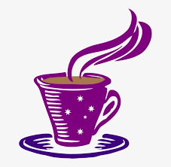  Keep your cool |  | Keep your cool |  | Keep your cool
Keep your cool |  | Keep your cool |  | Keep your cool
Keep your cool |  | Keep your cool |  | Keep your cool
Keep your cool |  | Keep your cool |  | Keep your cool
Keep your cool |  | Keep your cool |  | Keep your cool
Keep your cool |  | Keep your cool |  | Keep your cool
Keep your cool |  | Keep your cool |  | Keep your cool
Keep your cool |  | Keep your cool |  | Keep your cool
Keep your cool |  | Keep your cool |  | Keep your cool
Keep your cool |  | Keep your cool |  | Keep your cool

