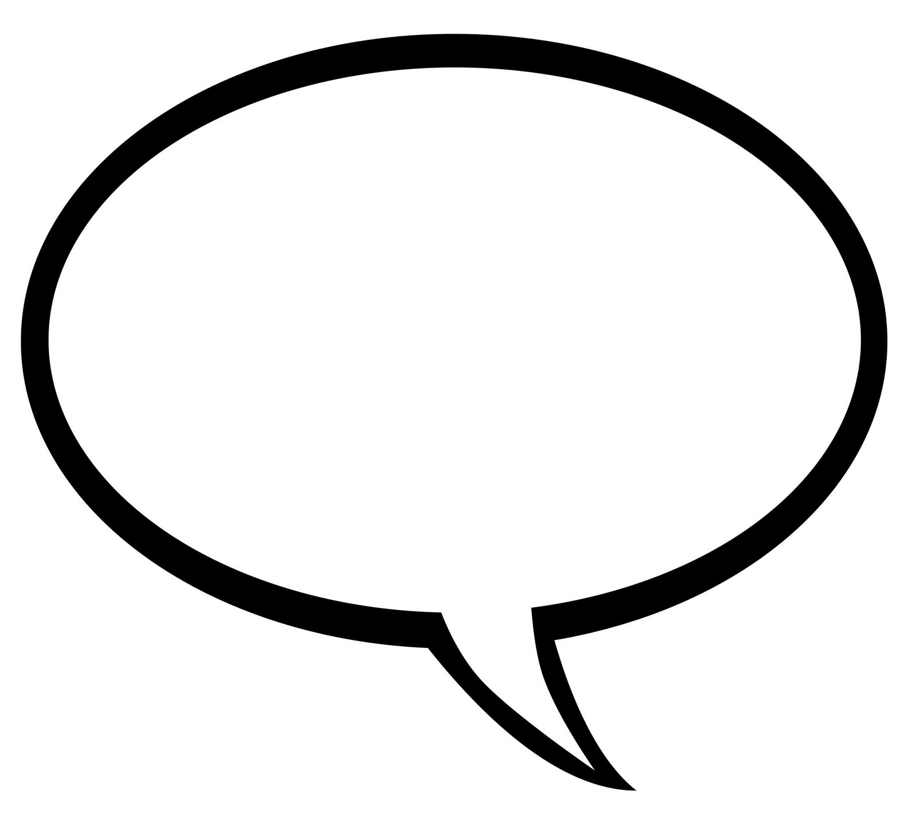

**I am good at...**

**I would like to share this about my culture…**

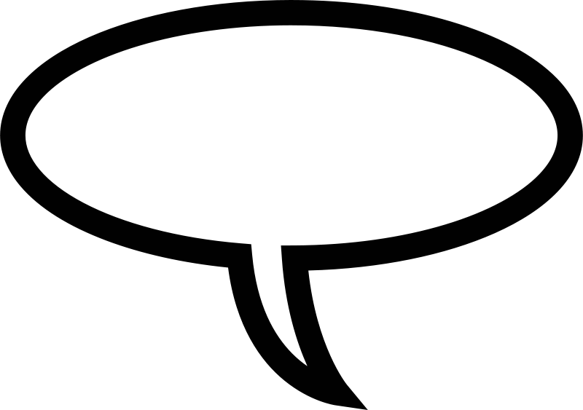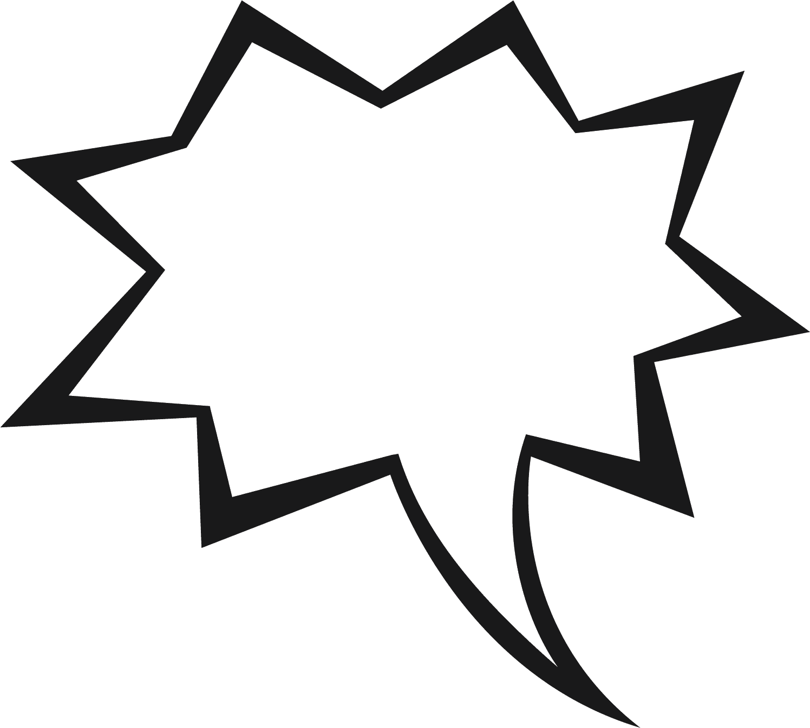

**My authentic self is…**

**I am a good friend because…**



**I am unique and beautiful because…**

**I know I am loved because…**



**I am proud of…**



