Invite and include  - Smile  - Say, “Hi”  - Introduce yourself  - Learn names | Invite and include  - Smile  - Say, “Hi”  - Introduce yourself  - Learn names | Invite and include  - Smile  - Say, “Hi”  - Introduce yourself  - Learn names | Invite and include  - Smile  - Say, “Hi”  - Introduce yourself  - Learn names
Invite and include  - Smile  - Say, “Hi”  - Introduce yourself  - Learn names | Invite and include  - Smile  - Say, “Hi”  - Introduce yourself  - Learn names | Invite and include  - Smile  - Say, “Hi”  - Introduce yourself  - Learn names | Invite and include  - Smile  - Say, “Hi”  - Introduce yourself  - Learn names
Everyone belongs at our school.  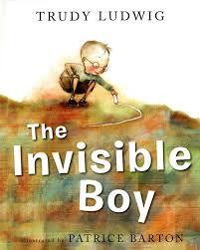  We fill buckets with kindness. | Everyone belongs at our school.  We fill buckets with kindness. | Everyone belongs at our school.  We fill buckets with kindness. | Everyone belongs at our school.  We fill buckets with kindness.
Everyone belongs at our school.  We fill buckets with kindness. | Everyone belongs at our school.  We fill buckets with kindness. | Everyone belongs at our school.  We fill buckets with kindness. | Everyone belongs at our school.  We fill buckets with kindness.

