Healing Hand
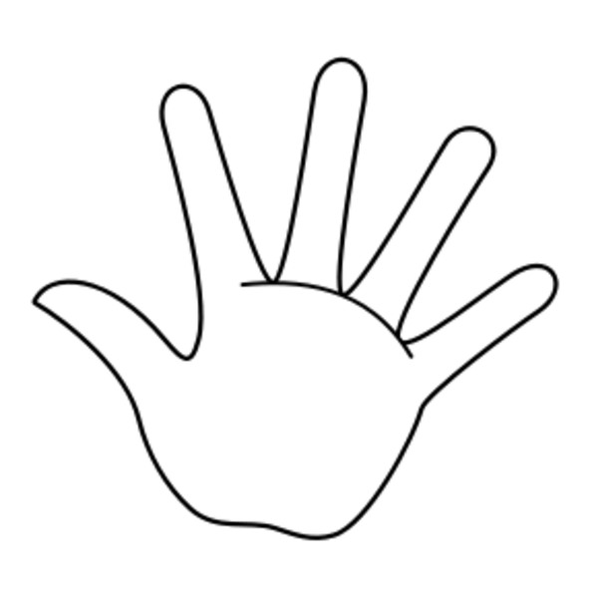
Instruct kindergarten to first grade students to draw a picture of a worry, concern, or problem they have on the hand.

