**Personal Mandala**

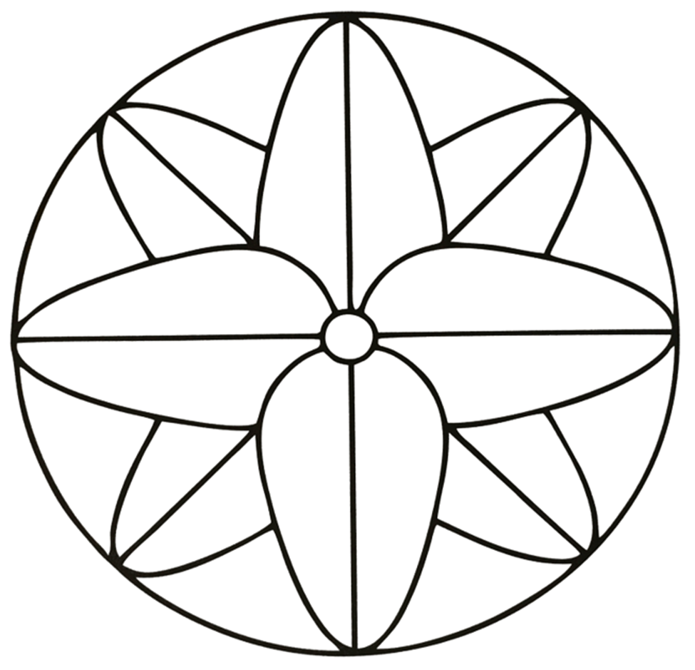

**Name_________________**

