Use personal power  to be an active  listener | Use personal power  to be an active  listener | Use personal power  to be an active  listener | Use personal power  to be an active  listener |  |  | Use personal powe to be an active listener
Use personal power  to be an active  listener | Use personal power  to be an active  listener | Use personal power  to be an active  listener | Use personal power  to be an active  listener | 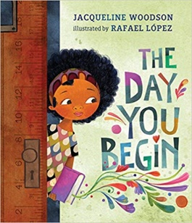  ce is heard. | Practice inclusive  behaviors to create a caring school where every voice is heard.
LISTEN  with your heart  - Focus on speaker  - Make eye contact  - Smile and nod  - Clarify  - Paraphrase | LISTEN  with your heart  - Focus on speaker  - Make eye contact  - Smile and nod  - Clarify  - Paraphrase | LISTEN  with your heart  - Focus on speaker  - Make eye contact  - Smile and nod  - Clarify  - Paraphrase | LISTEN  with your heart  - Focus on speaker  - Make eye contact  - Smile and nod  - Clarify  - Paraphrase |  |  | Use personal powe to be an active listener
LISTEN  with your heart  - Focus on speaker  - Make eye contact  - Smile and nod  - Clarify  - Paraphrase | LISTEN  with your heart  - Focus on speaker  - Make eye contact  - Smile and nod  - Clarify  - Paraphrase | LISTEN  with your heart  - Focus on speaker  - Make eye contact  - Smile and nod  - Clarify  - Paraphrase | LISTEN  with your heart  - Focus on speaker  - Make eye contact  - Smile and nod  - Clarify  - Paraphrase | ce is heard. | Practice inclusive  behaviors to create a caring school where every voice is heard.

