PRESCHOOL/TRANSITIONAL KINDERGARTEN LESSON #1
Gustavo the Shy Ghost
By Flavia Z. Drago

This book is about loneliness, bravery, and friendship. Gustavo is good at doing ghostly things like walking through walls, making objects fly, and glowing in the dark, but he is shy and some things are hard for him to do. He wants to make friends with the other monsters, but whenever he gets close to them, he realizes that they can’t see him. Gustavo loves to play the violin and decides to invite all the other monsters to a concert on the Day of the Dead.

FRAMEWORKS:

Social and Emotional Learning

(Self-Awareness, Social Awareness)
Gustavo the Shy Ghost is a book written to help students recognize and understand their own emotions and develop strategies to manage them. The story also explores how to learn to communicate feelings and needs effectively which is an important social skill in building friendships. Learning how to navigate social situations and build positive relationships are important skills for school and in life.

ASSET FOCUS: Positive Identity

This developmental asset category focuses on personal power, self-esteem, sense of purpose, positive view of personal future, and positive cultural identity. This internal asset is built by caring adults who support and affirm preschooler’s experiences, skills, competencies, and exploration of their world.

- Personal Power-The child can make choices that give a sense of having some influence over things that happen in her or his life. (#37)
- Self-Esteem-The child likes her or himself and has a growing sense of being valued by others. (#38)

DEVELOPMENTAL RELATIONSHIPS

These elements are built:
- Challenge Growth (Push me to keep getting better.) Expect my best, Stretch
- Share Power (Treat me with respect and give me a say.) Let me lead, Respect me

INTRODUCTION and WARM UP

- Smile and introduce yourself, “Hi, I am ____. I am your Project Cornerstone reader. Every month I will read a story and do some fun things with you.”
- Bring out your puppet (optional). Say to the students, “This is __________, my puppet.”
- If there is time, introduce your puppet to each child to learn their names.
- Have your puppet set some ground rules for Project Cornerstone time.
  - We listen. We take turns speaking. We are kind to each other.
- Have your puppet ask students to show you they are ready to listen to the story. Remind them to get into a listening position: Eyes forward looking at you, hands in lap, and legs in crisscross applesauce. Listening ears on, ready, set, start!

BOOK

Show students the book and read the cover and author’s name.
- Say, “This book is called Gustavo the Shy Ghost. Look at the cover of this book. What do you think it is about? What does it mean to be shy?”

Read the book and show students the illustrations. You may need to define some terms from the story.
- Paranormal - Not explainable on the basis of normal experience.
- Day of the Dead - A Mexican celebration where families honor their ancestors.

Ask the students:
- What was Gustavo afraid to do?
- What is a friend? What do friends do for each other?
- What special talent does Gustavo have?
- What made Gustavo glow?
- Do you have a special talent?
- Have you ever celebrated the Day of the Dead or a similar holiday to honor your ancestors?

ACTIVITY

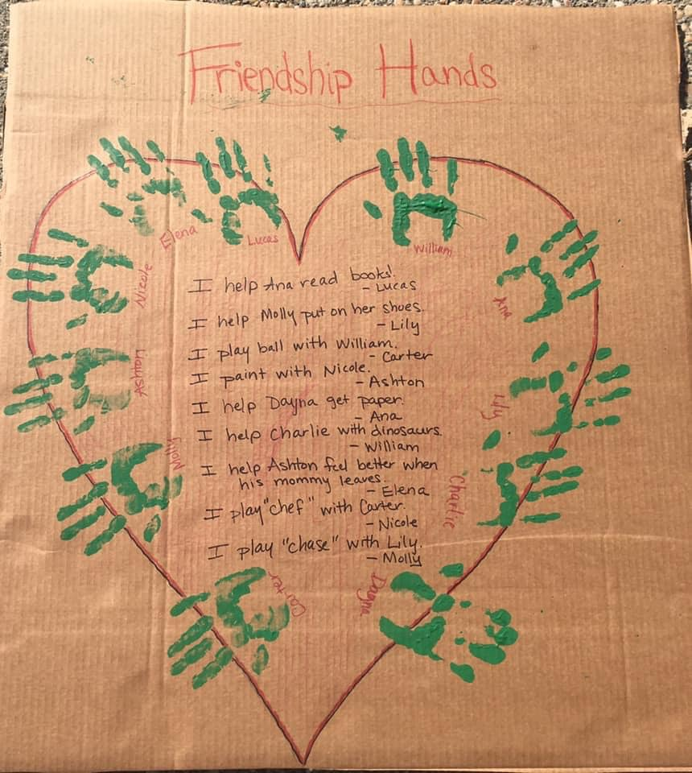Friendship Heart Poster
Materials: Draw a heart on a large poster board, paint, and markers
- Ask students what they like best about their friends. Write their words exactly as they say them.
- Have them paint their hands and make a hand print on the poster.
- Make sure everyone has their name on the poster.

Friendship Bean Bag Toss
Materials: You will need 1 bean bag.
- Toss the bean bag from hand to hand and sing: (to the tune “Did You Ever See a Lassie?”)
I have a good friend, a good friend, a good friend,
I have a good friend and his/her name is___________.
- Then toss the bean bag to the child who was named. Have the child toss it back. Repeat until every child has their name called.

EXTENSIONS
- As a follow up, read The Day of the Dead by Bob Barner. The book is about the Day of the Dead, a traditional holiday celebrated throughout Mexico and Central America to honor those who have departed. These are moments of celebration and should not sadden or scare us. It is actually the opposite; a colorful, positive, upbeat, family centered holiday that allows us to remember relatives and friends who have died but who live in our hearts and in our memories. There is a full lesson plan on the Project Cornerstone website under Los Dichos, Kindergarten: LD_DiaMuertos_LP_19.pdf (ymcasv.org)
- Role Play with students on How to Make a Friend – See handout for the Puppet script and role play ideas.
- Friendship Drawings - Have students draw a picture of something they like to do with a friend. Let them use paint, markers, crayons. Walk around and ask them to tell you about their picture. Write down what they say. You can put the finished drawings in a class book, post on a bulletin board, or send home.
- Let’s Go Fishing - Cut fish shapes out of paper and write a message about what a friend might do with them on each fish. (For example, “Sharing toys is fun” or "When someone gets hurt, I ask if I can help.”) Attach a paper clip to each fish. Place them on the floor and invite children to fish for them using a small magnet attached to a string on a pole (pole can be a paper towel tube or similar object). Read the messages aloud as children “catch” the fish.

