**Los Dichos Lesson #7**

***La Mariposa***

By Francisco Jiménez

**Dicho:** “The stronger your roots, the stronger your wings.”

**Asset Category:** Social Competencies

#33 Interpersonal Competence #34 Cultural Competence

#36 Peaceful Conflict Resolution

**Introduction**

*(Instructions: Read one paragraph or question in Spanish. Pause and let the teacher or volunteer read the same in English. Continue in the same way until done with the lesson script.)*

Hello boys and girls!

Today we will be reading a book called ***La Mariposa*** written by Francisco Jimenez and illustrated by Simón Silva. It is about the school year of a young boy, Francisco, who has recently moved to the United States. He is learning English as a second language and struggles in the classroom as he doesn’t understand his teacher or his classmates. He feels like an outsider and can only relate to the classroom’s caterpillar. Francisco sits and watches the caterpillar the entire day in order to escape from his reality. Over the course of the year, like the caterpillar, he evolves and gains self-confidence.

**Read the Story**

*Read the book in Spanish a page at a time and have the teacher or volunteer read the same page in English. Remember to show the illustrations.*

**Discussion Questions**

1. The author and the main character in the book are named Francisco. Do you think this might be a true story?
2. What sort of work did Francisco’s parents do?
3. Francisco and his family lived in Tent City. What does this mean?
4. How would life be for you as a migrant farmworker student?
5. Do you think it would be easy or difficult to constantly adjust to new homes, neighbors, schools, and friends?
6. How many of you know a second language? Was it difficult to learn it?
7. How do you think Francisco felt when he was unable to understand what the teacher and his classmates were saying?
8. Why do you think that Francisco’s teacher did not want him and Arthur to speak Spanish?
9. Is it important to feel proud of your ethnic background? What does our Dicho mean?
10. What do Francisco and the caterpillar/butterfly have in common?

**Activities**

**Option 1.- A Promise Butterfly**

Francisco struggled to learn language, but his powerful imagination helped him endure the situation. La Mariposa makes a subtle plea for tolerance in our homes, our communities, and our schools. It tells us about the importance of inclusion and making others feel welcomed and supported. Ask students to make a promise to become an UPstander and help their peers in need. Make a tissue paper butterflies to symbolize the promise.

 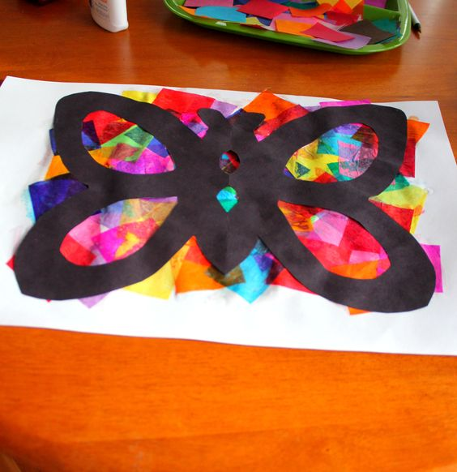 

**Option 2.- Know Your Worth**

1. Take out a $20 bill and show it to the class. Ask them who wants this $20 bill. To give you thumbs up for yes. Wait for their answer.

**Note: Make sure everyone understands this is an exercise. Students should answer honestly.**

1. Now, tell them you’ll gladly give it to them but first you need to crumble it. Crumble the bill.
2. Ask them again who wants this $20 billand wait for the students to reply.
3. Now, step on the bill. Stomp your feet on it and ask who wants the bill.
4. If necessary, wet the bill and crumble it again and ask who wants the bill. Probably, everyone will accept the bill. Right?
5. Ask how come even though this $20 bill is wet and crumbled they still want it.

Could it be that the bill is still worth 20 dollars? That’s right. Just like a $20 bill doesn’t change its value regardless the shape is in, our worth does not change even when people don’t treat us right. Francisco didn’t feel less because he couldn’t understand English. He didn’t feel less because he had no jacket. He knew his worth and his parents worth. Every one of us is important and worthy. Francisco took the high road and was able to forgive his classmate. He even gave him his drawing as a gift.

I hope all of you will be inspired by Francisco and will know your worth. No matter where you live, what your parents do for a living or the level of your language skills, your worth is as big as any other person on this Earth.

**Closure**

Thank you for your attention. Remember Francisco knew his worth. You can too. Let our Dicho “*The stronger your roots, the stronger your wings.*” sink in your heart. Appreciate who you are and where you come from. You’ll be able to go far in life, just like the author.

See you next month.

**Butterfly Templates**

