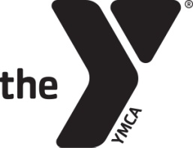
After School S.A.F.E. Framework for Lesson Planning
Theme: STEAM
Grade: K-3
Objective: to teach youth about molecules
 | Physical Activity – 30 Min. Daily | Wellness/Nutrition Education – 2x/month | Math and Literacy – 30-40 min. daily
Circle Component(s): | Arts Education – 1x/week | 21st Century Skills and STEAM – 2x/week | Global Learning – 1x/week
 | Leadership and Character Development – 1x/week | College and Career Readiness—2x/month | Service Learning – 1 project/quarter

Sequenced | Explain step-by- step the activity and how it builds on other activities | Activity: Magic Milk  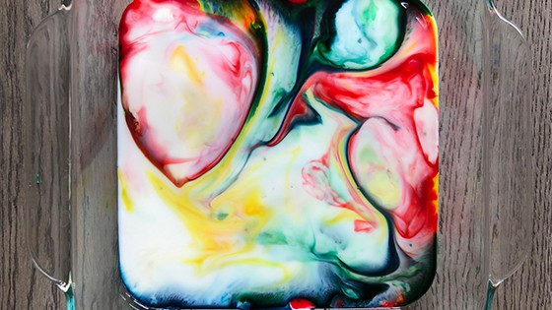  Materials Needed:  - Milk (2% or whole preferred)  - Dishwashing liquid  - Liquid food coloring  - Cotton swab  - A glass pan or dish  Steps:  - Pour a thin layer of milk in the pan until the milk covers the bottom.  - Add drops of food coloring to the milk. It’s okay if some of them start to mix. If that’s the case, you can talk to your kids about color mixing and how two colors combine to form a new color.  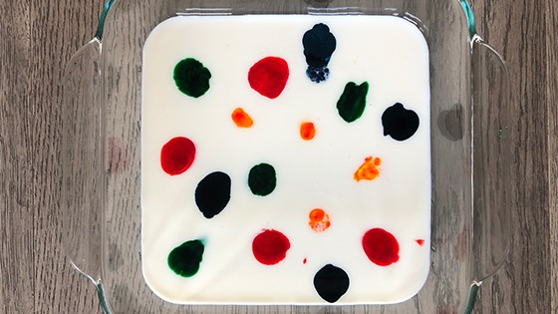  - Dip the cotton swab in dish soap and put it in the milk. If you don’t have cotton swabs around the house, you can add a drop of dish soap into the milk directly. I recommend the cotton swab just because you can control where you want the dish soap to go better.  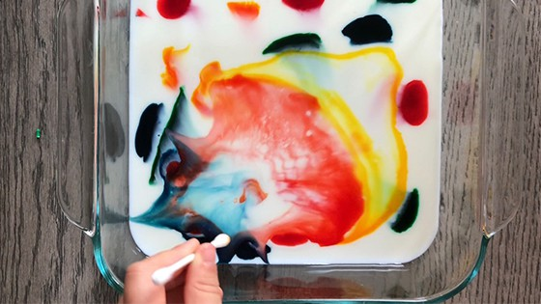  - Watch the colors run wild!  - Once the colors start to slow down, you can repeat #3 and watch the colors explode again. The explosion will slow down and stop eventually.  Magic Milk Explanation:  We drink milk every day. But have you ever stopped to think about what exactly is in milk? What is the science behind the magic milk?  Milk is composed of water, proteins, fats, vitamins, and minerals. The proteins and fats are susceptible to changes in the milk.  When you add the dish soap, the soap molecules race around to find the fat molecules in the milk. The fat molecules bend, twist, and roll in all directions as the soap molecules try to attach to them. The fat and soap molecules bump into the food coloring molecules, causing the busts of color.
Active | Hands on-engagement, demonstrate and practice skills | Youth will have the opportunity to experiment and observe the science behind milk.
Focus | Specific time and attention on skill development | 30 minutes
Explicit | Observation and reflection = validation of skills Review Objective | Do you think the experiment would work differently with a different type of milk?  - You can repeat the experiment using skim, 1%, 2%, and whole milk and see which one produces the best color eruption.  What happened when you put the cotton swab in the milk?  Why do you think it stopped moving around after a period of time?  Do you think the colors would move around the same if it was water instead of milk?
Alignment | Alignment of Common Core State Standards  (Two standards)
Language Development | List Vocabulary and Sight Words | Molecule: the smallest particle in a chemical element or compound; Molecules are made up of atoms

