[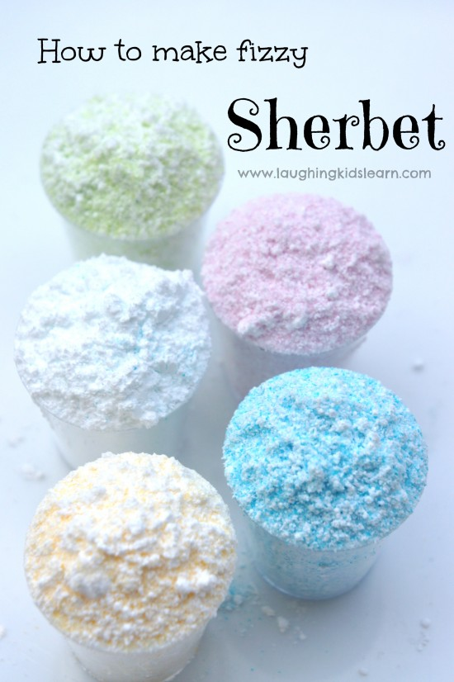](https://laughingkidslearn.com/wp-content/uploads/2014/07/taste-testing-homemade-sherbet.jpg)

**Directions:**

**Step 1:** Add 3 teaspoons of soft icing sugar to a medium sized bowl.

**Step2:** Next add 1 teaspoon of citric acid.

**Step 3:** If you wish for your sherbet to be flavored you might choose to add 2 teaspoons of raw Jell-o crystals or pop rocks

**Step 4:** For different colors you can add food coloring

**Step 5:** Mix well and serve

**The Science Behind what makes Sherbet Fizz**

Typically, when the citric acid and bi-carbonate mix together

with the saliva in the mouth it releases a gas, which causes a

fizzy chemical reaction. A similar fizzy reaction can be achieved

with just the use of citric acid and saliva. The icing sugar

sweetens the mixture.

**Picture:**

[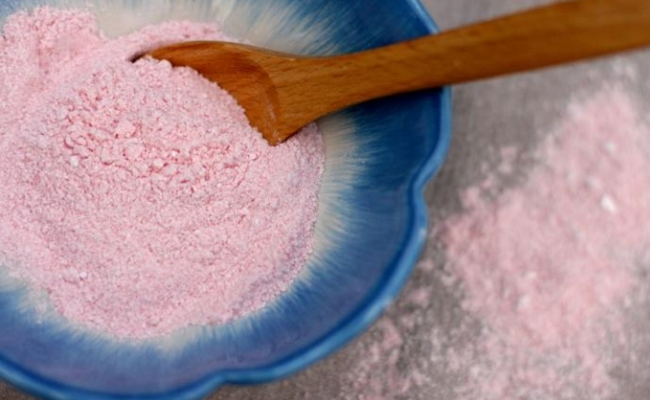](https://www.google.com/url?sa=i&url=https%3A%2F%2Fe-liquid-recipes.com%2Frecipe%2F2747678%2FDouble%2520Drip%2520Raspberry%2520Sherbet%2520(Remix)&psig=AOvVaw1dSuiyh8TmxdbGBgPx-qtd&ust=1585233440142000&source=images&cd=vfe&ved=0CAIQjRxqFwoTCMCMnIDttegCFQAAAAAdAAAAABAE)

**Fizzy Sherbet**

**Materials:**

-Soft Icing Sugar *(sugar powder)*

-Citric Acid *(sour salt)* for Baking  
-Food Coloring  
-Jell-o Crystals / Pop Rocks *(optional)*

-Cups or Ziplocks

-Bowl  
-Knives or spoons for mixing