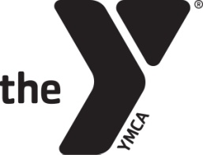
After School S.A.F.E. Framework for Lesson Planning
Theme: Butterfly Chromatography
Grade/Group: K-3
Objective:
 | Physical Activity – 30 Min. Daily | Wellness/Nutrition Education – 2x/month | Math and Literacy – 30-40 min. daily
Circle Component(s): | Arts Education – 1x/week | 21st Century Skills and STEAM – 2x/week | Global Learning – 1x/week
 | Leadership and Character Development – 1x/week | College and Career Readiness—2x/month | Service Learning – 1 project/quarter

Sequenced | Explain step-by- step the activity and how it builds on other activities | Activity: Butterfly Chromatography  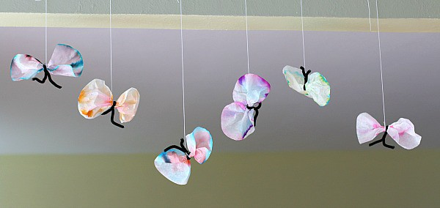  Materials:  - Non permanent markers  - White coffee filters  - Pencil  - Cups of water  - Black pipe cleaners  - Scissors  Steps:  - 1. Choose one marker to experiment with first. (Hint~ black and brown are the most exciting!)  - 2. Take one coffee filter. Put it on a newspaper or some kind of material to protect your table. Draw a thick circle around the center of the coffee filter where the ridged part meets the flat center. Use a pencil to write the color of the marker being used right in the center. (You’ll want to know what the original color was being used, and the pencil won’t smear and will remain intact after the experiment.)  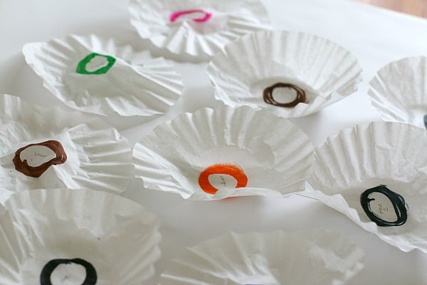  - Fold the coffee filter in half and then in half again, resulting in a cone shape.  - Get a short glass of water. Pull apart the cone shaped coffee filter so it balances right on the glass with the tip of the cone just touching the water. (Be sure NOT to let the marker circle go in the water, just the uncolored tip of the coffee filter cone.)  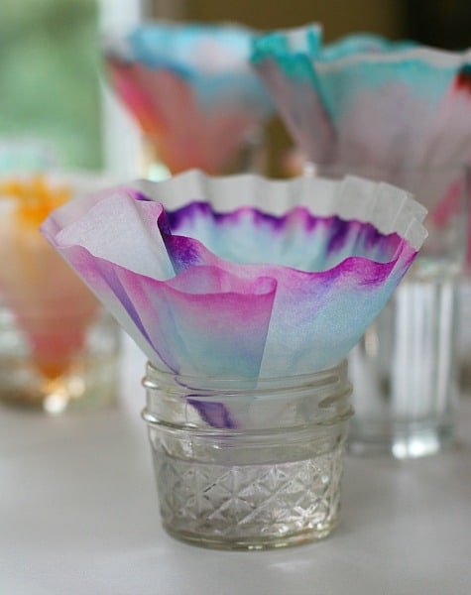  - Let it sit and watch what happens as the water begins to flow up the paper.  - Repeat with different colored markers.  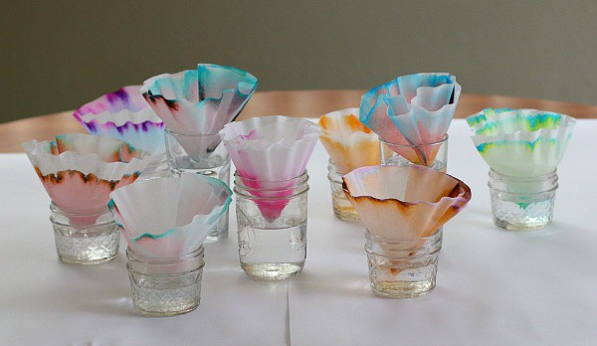  - After the water has reached the outer edge of the coffee filter, place it on a newspaper to dry.  - Once the coffee filters are dry you can observe the results.  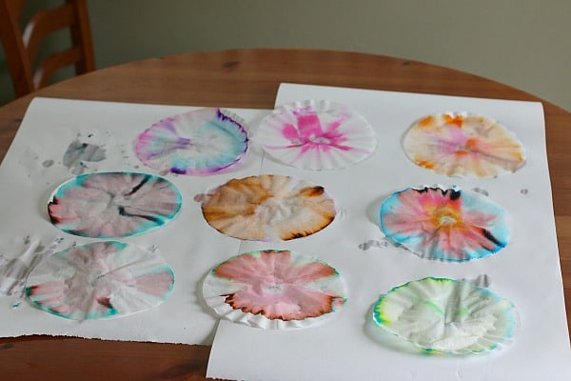  - Then time to create your butterfly!  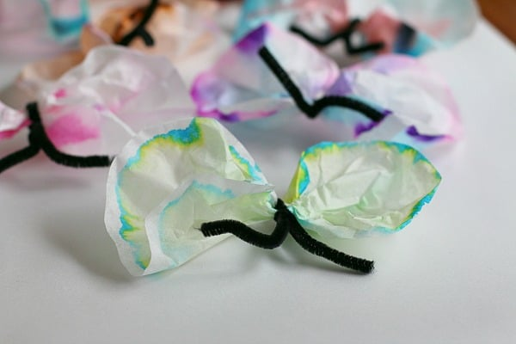  Below is a link to explain Chromatography to youth:  https://www.google.com/search?q=explaining+chromotagrpahy+to+kids&rlz=1C1GCEU_enUS836US837&oq=explaining+chromotagrpahy+to+kids&aqs=chrome..69i57j0.13547j1j9&sourceid=chrome&ie=UTF-8#kpvalbx=_MeV8XtKOBqPH0PEP1LueiAs87
Active | Hands on-engagement, demonstrate and practice skills | Youth will be hands on experimenting Chromatography
Focus | Specific time and attention on skill development | 30 minutes
Explicit | Observation and reflection = validation of skills Review Objective | What colors do you see? How many colors do you see? Which one do you find most interesting? Why?  What would happen if we did this experiment on regular paper?  What if we used multiple colors on 1 coffee filter?
Language Development | List Vocabulary and Sight Words | Chromatography: a way of separating out a mixture of chemicals, which are in a gas or liquid form, by letting them slowly pass  another substance.

